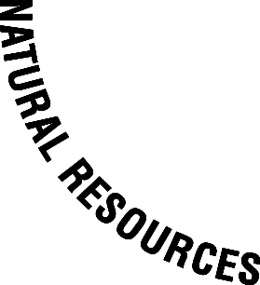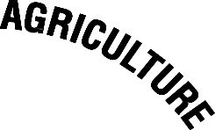

Lincoln University - Minorities in Agriculture, Natural Resources and Related Sciences (MANRRS)

Chapter Officers

President: Edward Robinson

Vice-President: Tia Orr

Secretary: Samantha McIntyre
Treasurer: Marques Gulley Parliamentarian: Cornell Bailey

Student Government Representative: Alex Gilliam

Advisor 1: Julius Moody
Advisor 2: Janet Haslerig

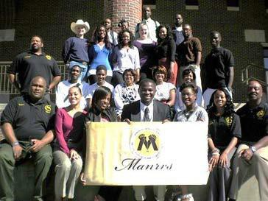
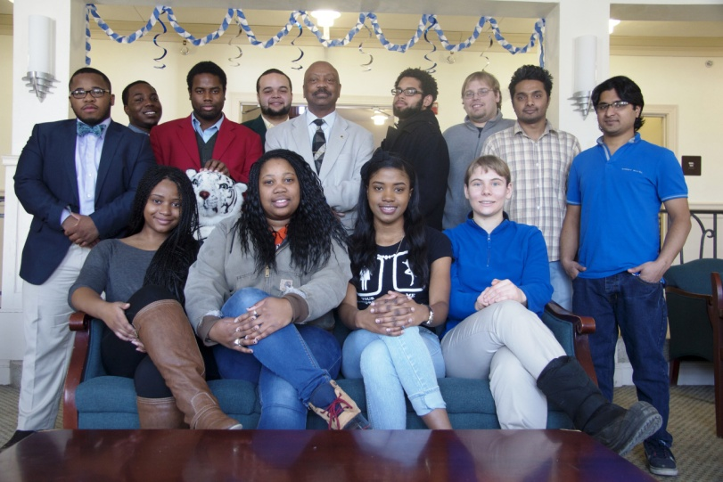

Community Service

Farmers Market

April 2014 marked the fifth year of Lincoln University Farmers market and aquaculture programs. The Farmers Market was initiated by MANRRS students and the Lincoln University Cooperative Extension Program in 2009. Since this time, the LU Farmers Market has grown substantially with multiple local vendors and partnered which included the Downtown Jefferson City Association. The Farmers Market relocates downtown during the month of May near the Governor’s Mansion (9:00 am to noon). This is due to the fact that LU’s campus gets busy at that time of the year. The majority of the produce by the MANRRS students are locally grown on the University farm. MANRRS members plant and harvested various fruits (watermelons and cantaloupe) and vegetables (peppers, collard greens, okra, cucumbers, black-eye peas, cabbage, tomatoes, lettuce. The majority of the vegetables were from heirloom seeds. MANRRS members raised and marketed prawns and striped bass. In addition, heirloom seeds were packaged, promoted and sold. Chapter members also distributed nutritional information and recipes for the produce.
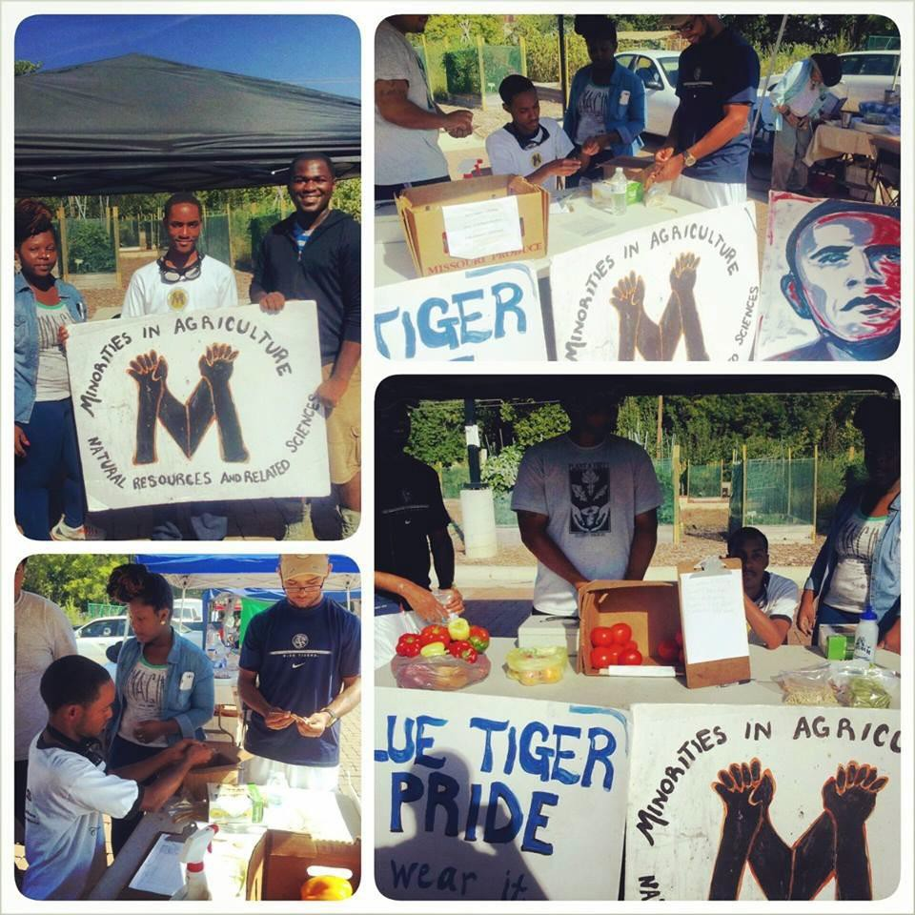

MANRRS Honeybee project update

The Lincoln University of Jefferson City, MO (LU) chapter of Minorities in Agriculture, Natural Resources and Related Sciences (MANRRS) has participated in numerous campus and community events as well as attended and participated in the National Conference and Regional Workshop. These learning opportunities have positively influenced LU MANRRS. LU MANRRS has won (4) consecutive Chapter of the Year Regional Awards.

September 2014 - April 3, 2015:
Under the mentorship of Dr. James Wetzel and Mr. Julius Moody, LU MANRRS students were awarded a grant through USDA NRCS to engage in basic husbandry of honeybees as well as the marketing of colonies and their products at a farmers market. The Grant purchased pre-milled hive components and equipment needed to produce 15 queen-right colonies. The grant will lead an effort to promote and establish native plant pollinator gardens and the establishment of an apiary to emphasize the importance of bee’s contribution to agriculture as pollinators. The hives will be placed adjacent to raised bed gardens with annual and perennial plants to be utilized by bees and other native insects. Fees or donations to offset future material needs will be collected for removal of feral colonies perceived as pest. Students will track expenditures and develop a marketing strategy. The LU MANRRS students are expecting a busy spring 2015.

A second LU MANRRS objective is to add additional professional members to our chapter. The most recent professional members are Reverend Al Sampson and Ms. Margaret Jacobs. Rev Sampson supports our honeybee project and campus global heirloom seed bank. Rev. Sampson, Ms. Jacobs and Ms. Audrey Gardner of Tatene Theis of Senegal West Africa are pending MANRRS members. Ms. Gardner has supported our third year program for LU heirloom to Africa.

Community Service – continued

Honeybee Project

LU MANRRS students were awarded a grant via USDA NRCS to assist LU with the overall restoration of the local and regional population of honey bees. The grant will lead an effort to promote and establish native plant pollinator gardens and the establishment of an apiary to emphasize the importance of bee’s contribution to agriculture as pollinators. We have acquired pre-milled hive components and equipment required to produce (15) new colonies to be placed adjacent to raised bed gardens with annual and perennial plants to be utilized by bees and other native insects. Fees / donations to offset future material needs will be collected for removal of feral colonies perceived as pest. Students will track expenditures and develop a marketing strategy.

MANRRS students below: Constructing and monitoring honey bee hives.

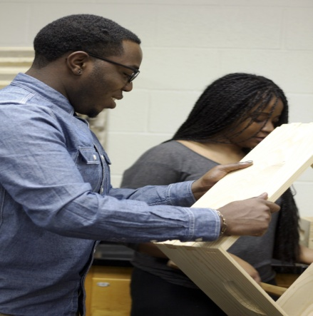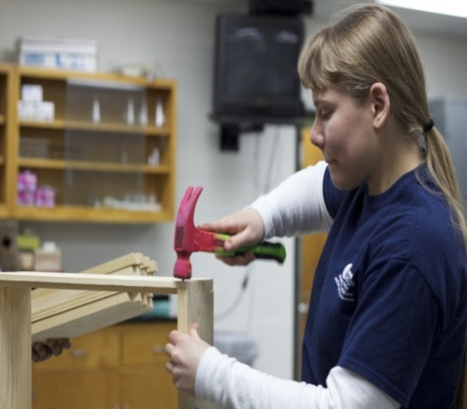

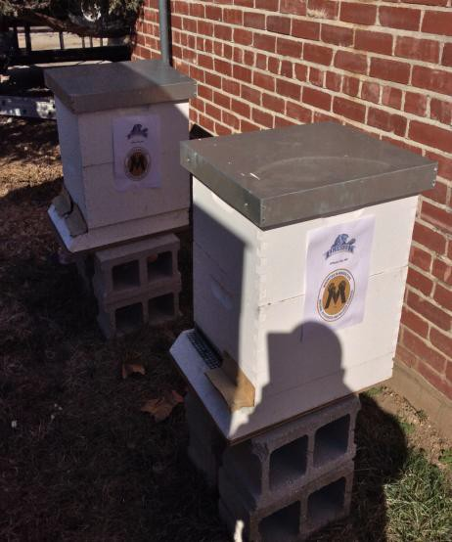
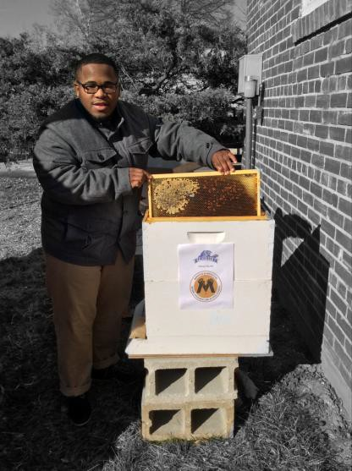

Community Service – Continued

Farmers Market
Starting late June through early September, the LU MANRRS chapter participated in the Lincoln University Farmer’s Market. A variety of fresh vegetables and fruit (e.g., mushroom, watermelons, cucumbers, bell peppers, okra, tomatoes, collard greens, black eyed peas, heirloom seeds and etc) were sold at the Market.

. 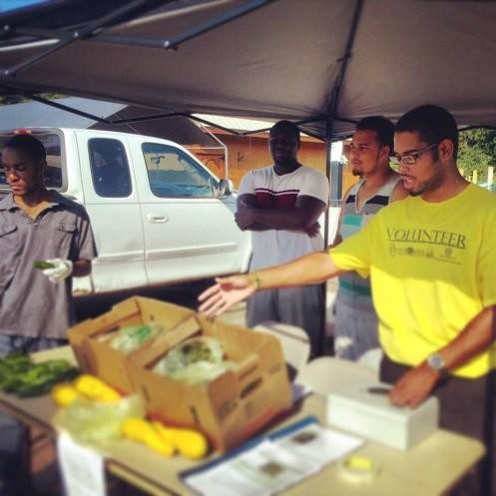 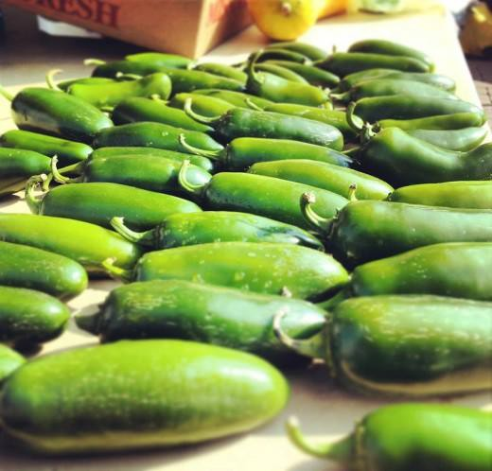

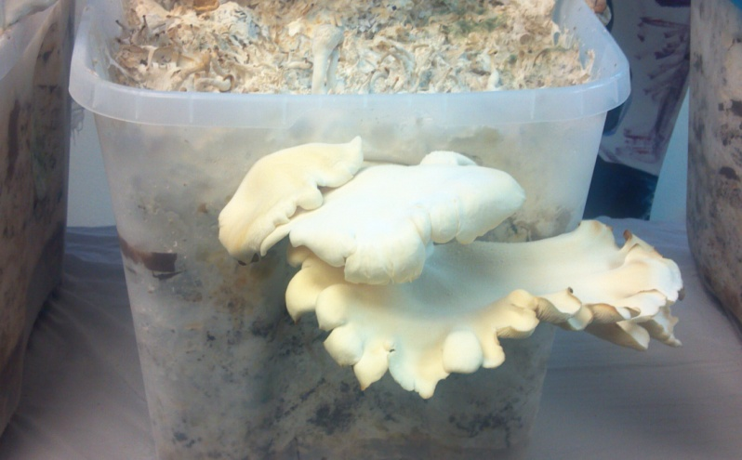

Global Promotion of the National Society

Heirloom Seed Donation to Africa

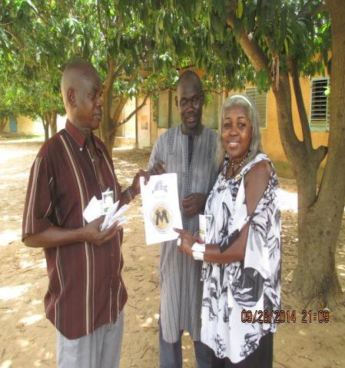
During July and September 2014, approximately 10 pounds of LU MANRRS heirloom vegetable seeds consisting of onions, lettuce, cabbage, okra, sweet corn, black- eyed peas, green beans, chili peppers and collard greens were donated to Youth Action Without Borders (YAWB). YAWB is a non-profit organization based in Atlanta, GA. Its mission is
to provide a multicultural experience for youths in Senegal for ages 5-23. This organization seeks to raise awareness of communication technology, educational opportunities and modern day farming techniques to youth in Dakar, Senegal. The heirloom seeds were planted near the Senegal River by
the village of Ngaparou Saly. Ms. Audrey Gardner, Ambassador, a pending MANRRS member, helped coordinated our third year program for LU heirloom seeds to Africa. Our primary objective is to provide a sustainable and relatively inexpensive food source for a less developed country and increase awareness of the National society.

