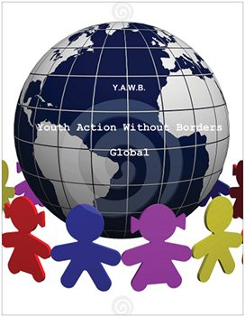

Travel Checklist

Documents and money

- Passport

- Drivers license or other official ID

- Visa (if necessary)

- Passport scan (don't forget to email to yourself if lost)

- Address book and emergency numbers and contact details

- Travel tickets (airplane, train, bus)

- Directions

- Hotel contact details

- Map and guide book

- Cash in foreign currency (if applicable)

- Get a Credit card, debit card or ATM card

Carryon baggage

- Camera, batteries, film or memory card

- Notebook and pen

- On the road entertainment: book, magazine, playing cards, games or music player

- Room for souvenirs

- Power plug adapters

- Keys

- Phone

- Watch

- Wallet

Suitcase

- Suitcase of the right size

- Luggage ID tags

- Luggage locks

- Travel alarm clock

- Mini sewing kit, scissors - keep in checked baggage

- Laundry bag, Ziploc plastic bags, soap packets, travel iron

- Travel first aid kit (incl.Imodium, salt tablets, plasters, motion sickness pills etc.)

- Pillow, earplugs

- Laptop (if applicable)

- Flashlight with batteries

- Binoculars

- Phone charger

- Electric adapter if traveling to a country with different electric wattage

- Purse or a handbag

- Mosquito repellent and net (if traveling to areas with high risk of mosquitoes)

Clothing

- Socks

- Undergarments

- Trousers

- Jeans

- Skirts

- Shorts

- Shirts, blouses, t-shirts

- Swimsuit

- Bath towels, Hand towels

- Hat (sun hat or winter hat, depending on the weather)

- Sunglasses

- Jacket

- Raincoat

- Sensible shoes; sandals for the beach

- Pajamas

- Formal or Dressy clothing if attending an event

Toiletries

- Comb or a brush

- Shaver, razor, shaving cream

- Aftershave, perfume

- Toothbrush, toothpaste, dental floss, mouthwash, lip balm

- Deodorant

- Cotton balls

- Soap, shampoo, face wash

- Toilet Tissues

- Lotion and facial moisturizer

- Sunscreen

- After-sun lotion

- Glasses, contact lenses, contact Lens solution

- Prescription medicines and their prescription if you require any fill ups

Food/Snacks

- Breakfast bars

- Chips and cookies

- Peanuts

- Coffee/Tea and powder or liquid creamers travel size

- Sugar packets

- ETC. (whatever you would like to eat of your choice

